**United States Department of Agriculture**

Food and Nutrition Service

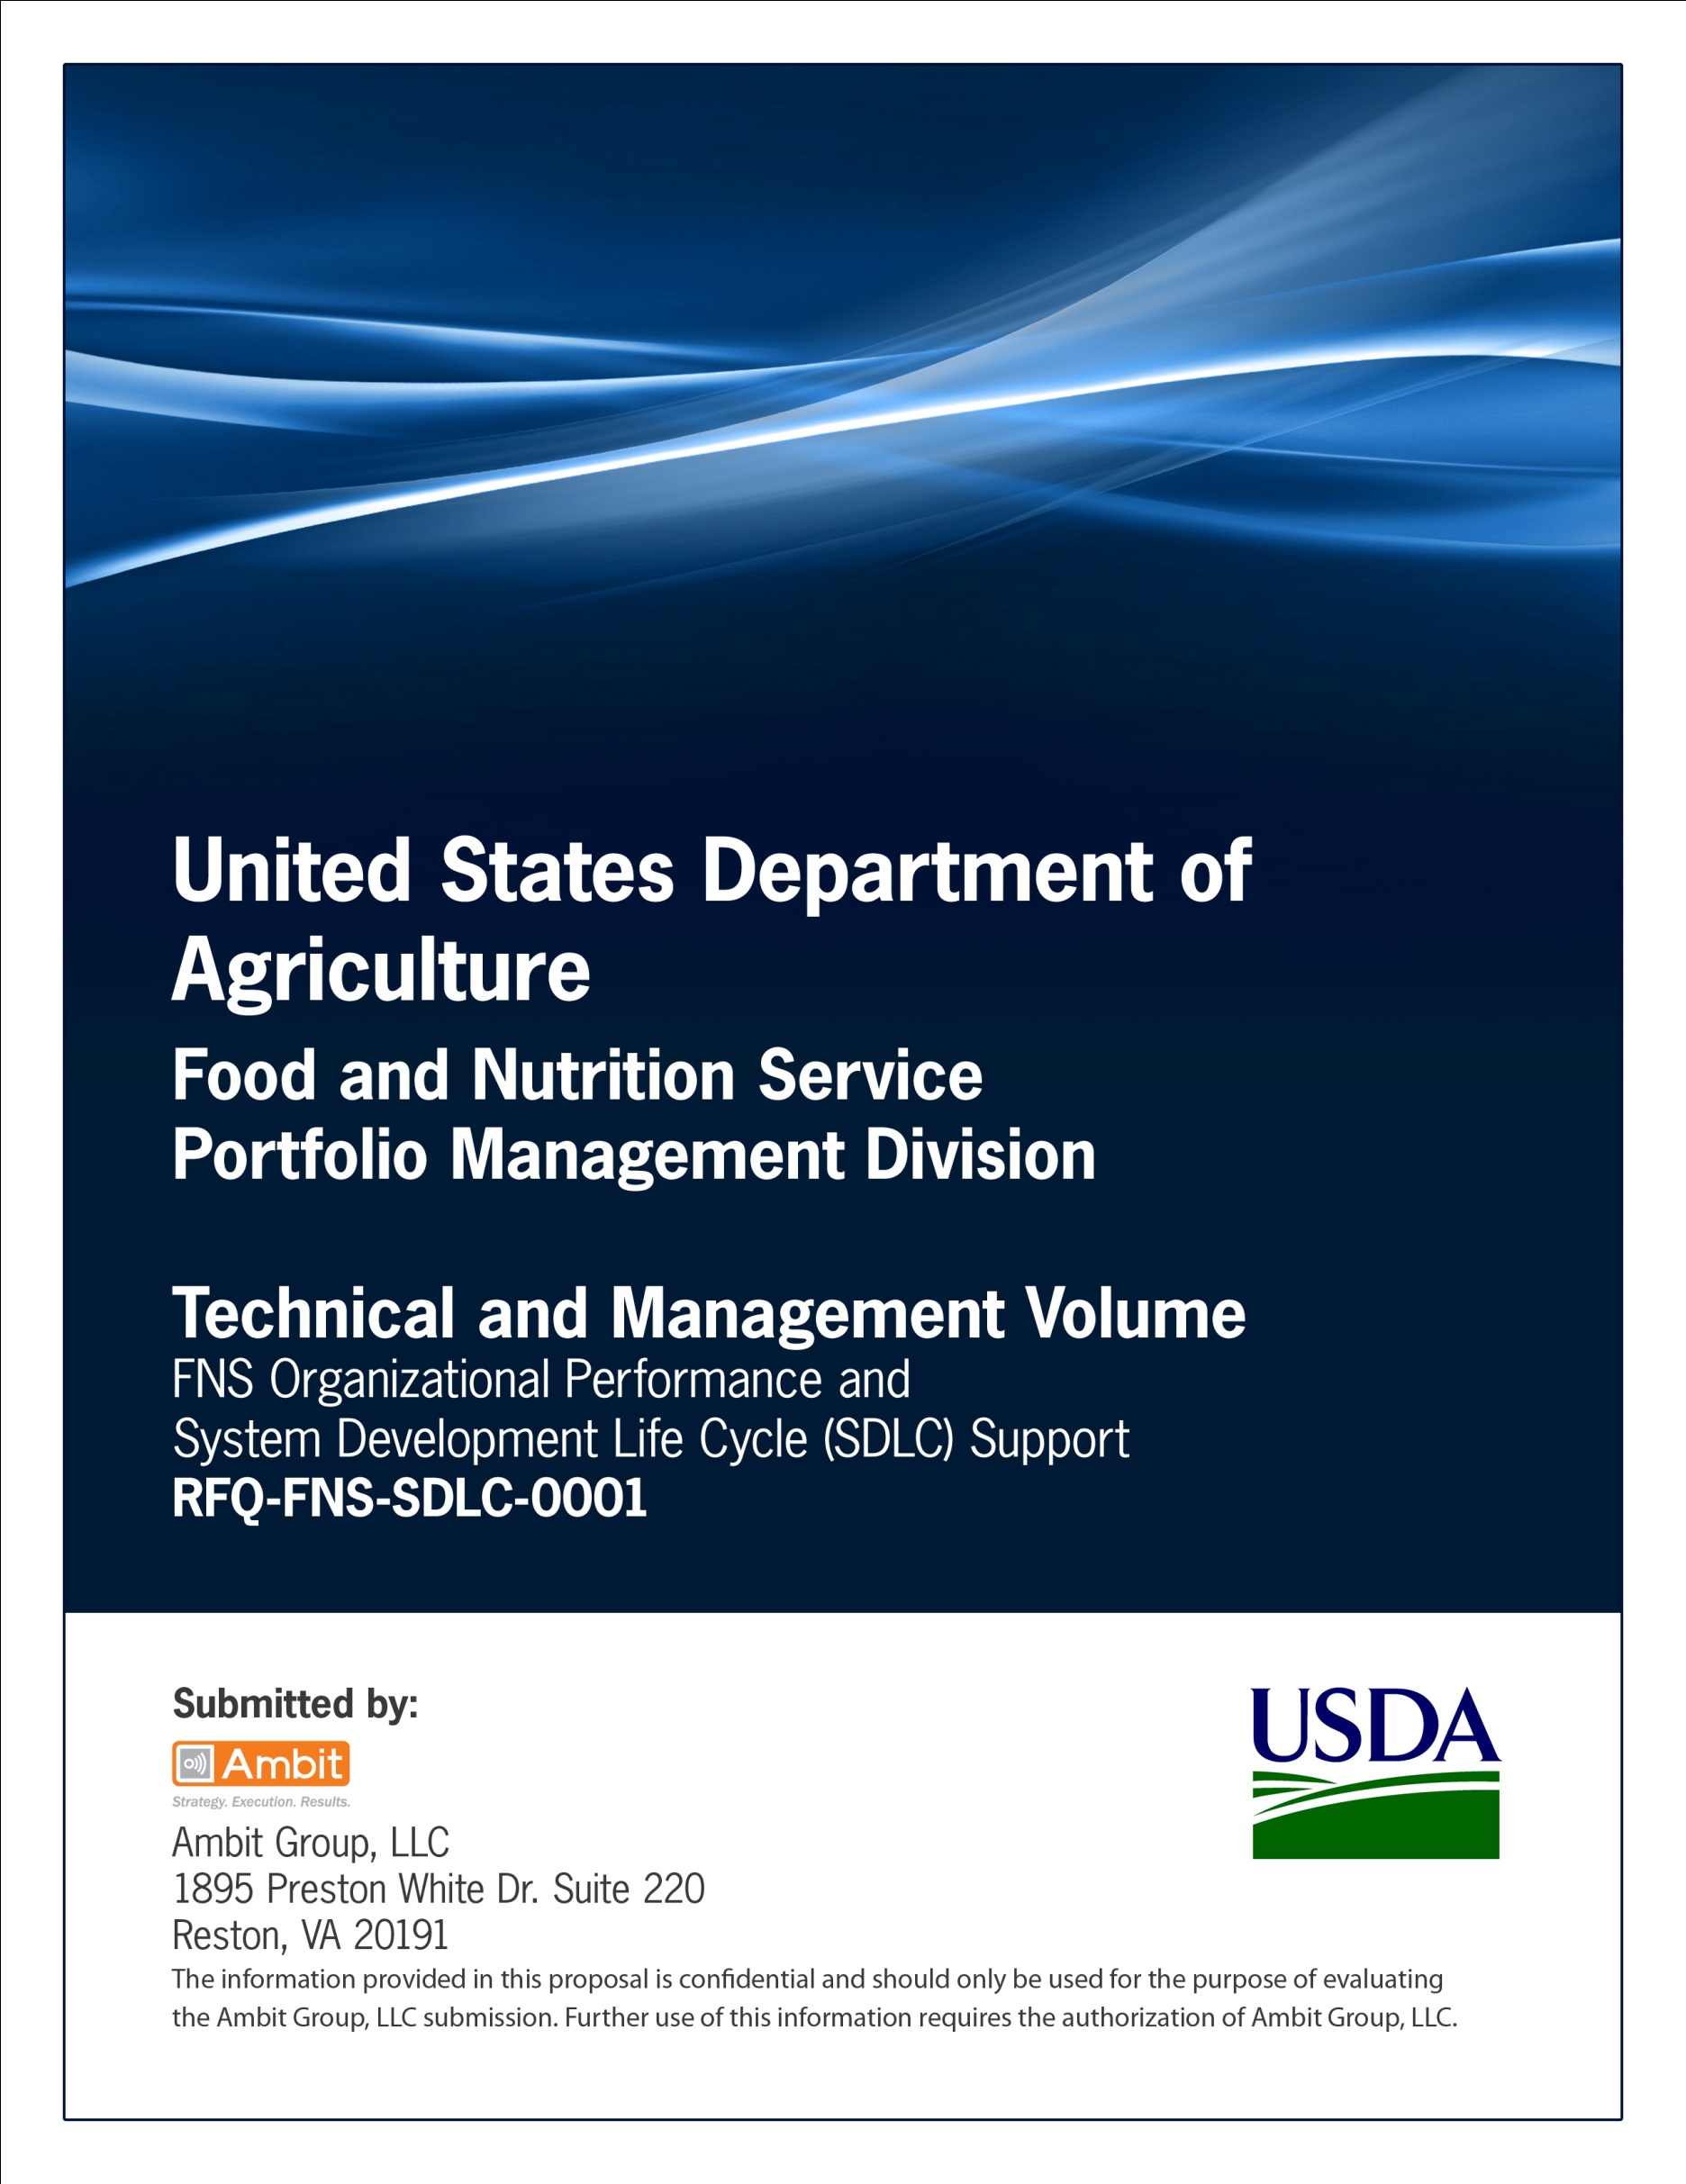

**FNS Office of Information Technology**

**Portfolio Management Division (PMD)**

**FNS Test Plan Template**

**for**

**[Project or System Name]**

**Version 1.1**

September 09, 2013

**Revision History**

|  |  |  |  |
| --- | --- | --- | --- |
| **Version** | **Date** | **Author** | **Change Description** |
| 1.0 | 03-13-2013 | IT Governance Branch (ITGB) | Created the document. |
| 1.1 | 09-09-2013 | IT Governance Branch (ITGB) | Re-formatted the document. |
| 1.2 |  |  |  |
| 1.3 |  |  |  |

**Contact Information**

|  |  |
| --- | --- |
| **Area of Concern** | **Contact Person** |
| IT Governance Lead | Kevin Russ |
| SDLC Coordinator | Syed Jaffery |
| ITIRB Coordinator | Sunny Dilawari |
| Portfolio Management Division Director, Chief Portfolio Officer | Jacqueline Butler |
| Program Management Branch Chief | Allison Willcox |

Contents

Glossary 4

1. General Information 5

1.1. Purpose 5

1.2. Scope 5

1.3. System Overview 5

2. Test Definitions 5

2.1. Types of Testing to be Performed 5

2.2. Requirements to be Tested 7

2.3. Expected Results 7

2.4. Test Hierarchy 8

2.5. Extent of Test 8

2.6. Test Data 8

2.7. Output Notification 8

2.8. Support Software 8

2.9. Error Handling 8

2.10. Test Conditions 8

2.11. Test Constraints 8

3. Test Execution 8

3.1. Test Schedule 8

3.2. Test Progression 9

3.3. Test Criteria 9

3.4. Test Control 9

3.5. Test Procedures 9

Appendix A: Test Scripts 10

Appendix B: Test Cases 11

Appendix C: References 12

Approvals/Signatures 13

# Glossary

| **Acronym** | **Description** |
| --- | --- |
|  |  |
|  |  |
|  |  |
|  |  |
|  |  |
|  |  |
|  |  |
|  |  |

# General Information

## Purpose

Describe the purpose of the unit and integration test plan.

## Scope

Describe the scope of the unit and integration test plan.

## System Overview

Describe the system overview.

# Test Definitions

## Types of Testing to be Performed

Outline the project team’s agreed upon change request (CR) process flow. The following outlines a generic change request process flow.

**Unit Testing**

Describe test cases to be part of the Unit Testing. This section should cover the below for the Unit Test Cases:

* Test Risks/Issues
* Items to be Tested/Not Tested
* Test Approach(s)
* Test Regulatory/Mandate Criteria
* Test Pass/Fail Criteria
* Test Entry/Exit Criteria
* Test Deliverables
* Test Suspension/Resumption Criteria
* Test Environmental/Staffing/Training Needs

**Integration Testing**

Describe test cases to be part of the Integration Testing. This section should cover the below for the Integration Test Cases:

* Test Risks/Issues
* Items to be Tested/Not Tested
* Test Approach(s)
* Test Regulatory/Mandate Criteria
* Test Pass/Fail Criteria
* Test Entry/Exit Criteria
* Test Deliverables
* Test Suspension/Resumption Criteria
* Test Environmental/Staffing/Training Needs

**Functional Testing**

Describe test cases to be part of the Functional Testing. This section should cover the below for the Functional Test Cases:

* Test Risks/Issues
* Items to be Tested/Not Tested
* Test Approach(s)
* Test Regulatory/Mandate Criteria
* Test Pass/Fail Criteria
* Test Entry/Exit Criteria
* Test Deliverables
* Test Suspension/Resumption Criteria
* Test Environmental/Staffing/Training Needs

**Regression Testing**

Describe test cases to be part of the Regression Testing. This section should cover the below for the Regression Test Cases:

* Test Risks/Issues
* Items to be Tested/Not Tested
* Test Approach(s)
* Test Regulatory/Mandate Criteria
* Test Pass/Fail Criteria
* Test Entry/Exit Criteria
* Test Deliverables
* Test Suspension/Resumption Criteria
* Test Environmental/Staffing/Training Needs

**System Testing**

Describe test cases to be part of the System Testing. This section should cover the below for the System Test Cases:

* Test Risks/Issues
* Items to be Tested/Not Tested
* Test Approach(s)
* Test Regulatory/Mandate Criteria
* Test Pass/Fail Criteria
* Test Entry/Exit Criteria
* Test Deliverables
* Test Suspension/Resumption Criteria
* Test Environmental/Staffing/Training Needs

**Load Testing**

Describe test cases to be part of the Load Testing. This section should cover the below for the Load Test Cases:

* Test Risks/Issues
* Items to be Tested/Not Tested
* Test Approach(s)
* Test Regulatory/Mandate Criteria
* Test Pass/Fail Criteria
* Test Entry/Exit Criteria
* Test Deliverables
* Test Suspension/Resumption Criteria
* Test Environmental/Staffing/Training Needs

**Performance Testing**

Describe test cases to be part of the Performance Testing. This section should cover the below for the Performance Test Cases:

* Test Risks/Issues
* Items to be Tested/Not Tested
* Test Approach(s)
* Test Regulatory/Mandate Criteria
* Test Pass/Fail Criteria
* Test Entry/Exit Criteria
* Test Deliverables
* Test Suspension/Resumption Criteria
* Test Environmental/Staffing/Training Needs

**User Acceptance Testing**

Describe test cases to be part of the User Acceptance Testing. This section should cover the below for the User Acceptance Test Cases:

* Test Risks/Issues
* Items to be Tested/Not Tested
* Test Approach(s)
* Test Regulatory/Mandate Criteria
* Test Pass/Fail Criteria
* Test Entry/Exit Criteria
* Test Deliverables
* Test Suspension/Resumption Criteria
* Test Environmental/Staffing/Training Needs

## Requirements to be Tested

Describe all the requirements to be tested.

## Expected Results

Describe all the expected results from the tests.

## Test Hierarchy

Describe the Test hierarchy.

## Extent of Test

Describe the extent of Testing to be performed.

## Test Data

**Input Test Data Control**

Describe the input test data control.

**Output Test Data Control**

Describe the output test data control.

**Data Recovery**

Describe the data recovery procedures.

**Test Data Handling**

Describe the test data handling.

## Output Notification

Describe the output notification(s).

## Support Software

Describe the support software(s) used.

## Error Handling

Describe the Error Handling procedures.

## Test Conditions

Describe the Test Conditions.

## Test Constraints

Describe the Test Constraints.

# Test Execution

## Test Schedule

Describe the test schedule.

## Test Progression

Describe the test progression.

## Test Criteria

**Tolerance**

Describe the test Tolerance criteria.

**Samples**

Describe the test Samples.

**System Breaks**

Describe the test System Breaks.

## Test Control

Describe the Test Control mechanisms.

## Test Procedures

**Setup**

Describe the Test Setup procedures.

**Initialization**

Describe the Test Initialization procedures.

**Preparation**

Describe the Test Preparation procedures.

**Termination**

Describe the Test Termination procedures.

**Test Cycle Performance Activities**

Describe the Test Cycle Performance Activities.

# Appendix A: Test Scripts

List all the test scripts for the system.

# Appendix B: Test Cases

List all the test cases for the system.

# Appendix C: References

Insert the name, version number, description, and physical location of any documents referenced in this document. Add rows to the table as necessary.

The following table summarizes the documents referenced in this document.

|  |  |  |
| --- | --- | --- |
| **Document Name** | **Description** | **Location** |
| Document Name and Version Number | Document description | URL or Network path where document is located |
|  |  |  |
|  |  |  |

# Approvals/Signatures

The undersigned acknowledge that they have reviewed the [name of document] document and agree with the information presented within this document. Changes to this document will be coordinated with, and approved by, the undersigned, or their designated representatives.

|  |  |  |  |
| --- | --- | --- | --- |
| Signature: |  | Date: |  |
| Print Name: |  |  |  |
| Title: |  |  |  |
| Role: | [Project or System Name] Project Manager |  |  |
|  |  |  |  |
| Signature: |  | Date: |  |
| Print Name: |  |  |  |
| Title: |  |  |  |
| Role: | [Project or System Name] Business Owner |  |  |
|  |  |  |  |
| Signature: |  | Date: |  |
| Print Name: |  |  |  |
| Title: |  |  |  |
| Role: | Organization’s Approving Authority |  |  |